**Name**: Paramprakash Makwana

**Module 4 – Introduction to DBMS(Extra Lab)**

Lab 1.3: Create a database called library_db and a table books with columns: book_id, title, author, publisher, year_of_publication, and price. Insert five records into the table.

Ans:- CREATE DATABASE library_db

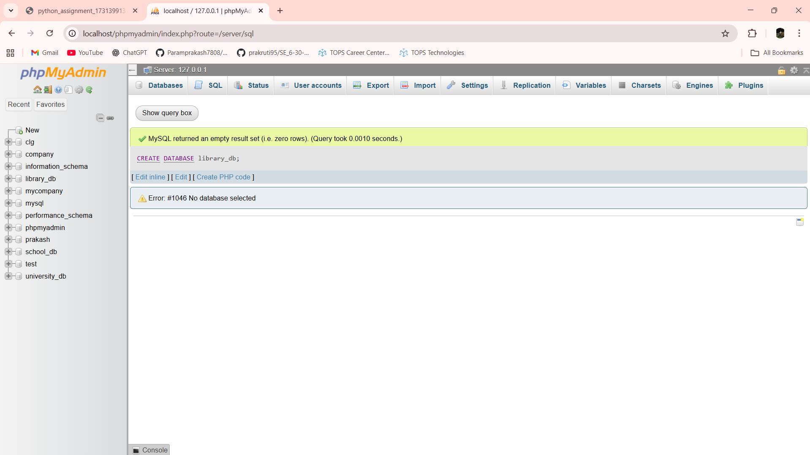

CREATE TABLE books (book_id INT PRIMARY KEY,title VARCHAR(100),author VARCHAR(100),publisher VARCHAR(100),year_of_publication INT,price int);

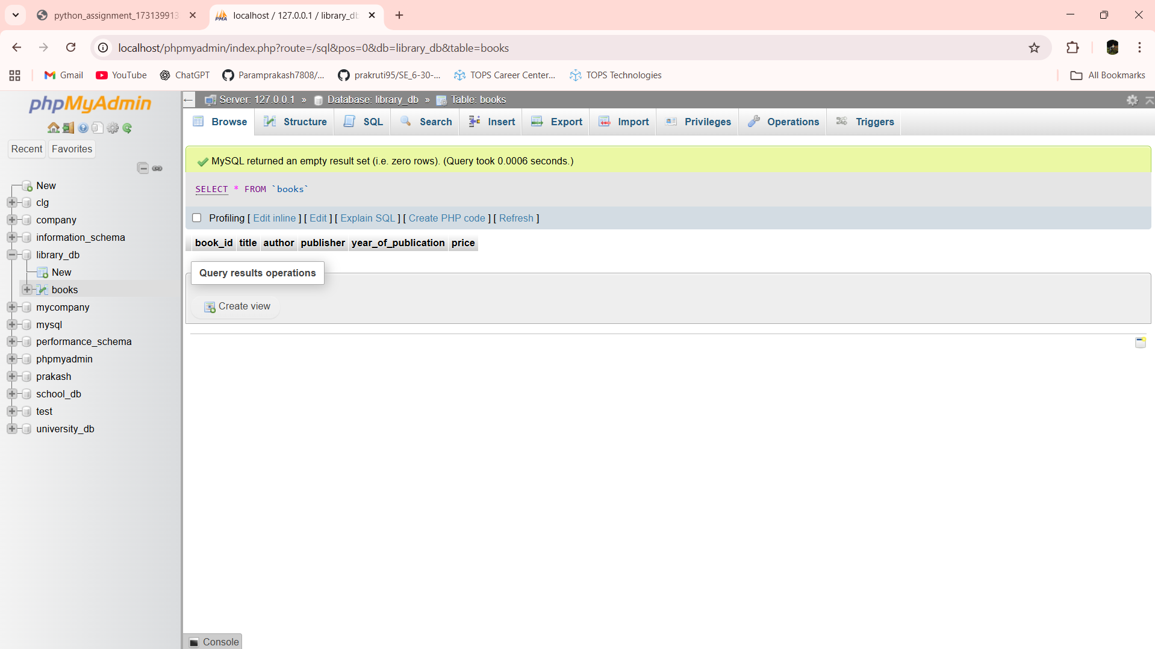

INSERT INTO books VALUES

(1, 'The Alchemist', 'Paulo Coelho', 'HarperCollins', 1988, 399.00),

(2, 'Clean Code', 'Robert C. Martin', 'Prentice Hall', 2008, 799.00),

(3, 'Atomic Habits', 'James Clear', 'Penguin', 2018, 499.00),

(4, 'Think Like a Monk', 'Jay Shetty', 'Simon & Schuster', 2020, 450.00),

(5, 'Rich Dad Poor Dad', 'Robert Kiyosaki', 'Warner Books', 1997, 350.00);

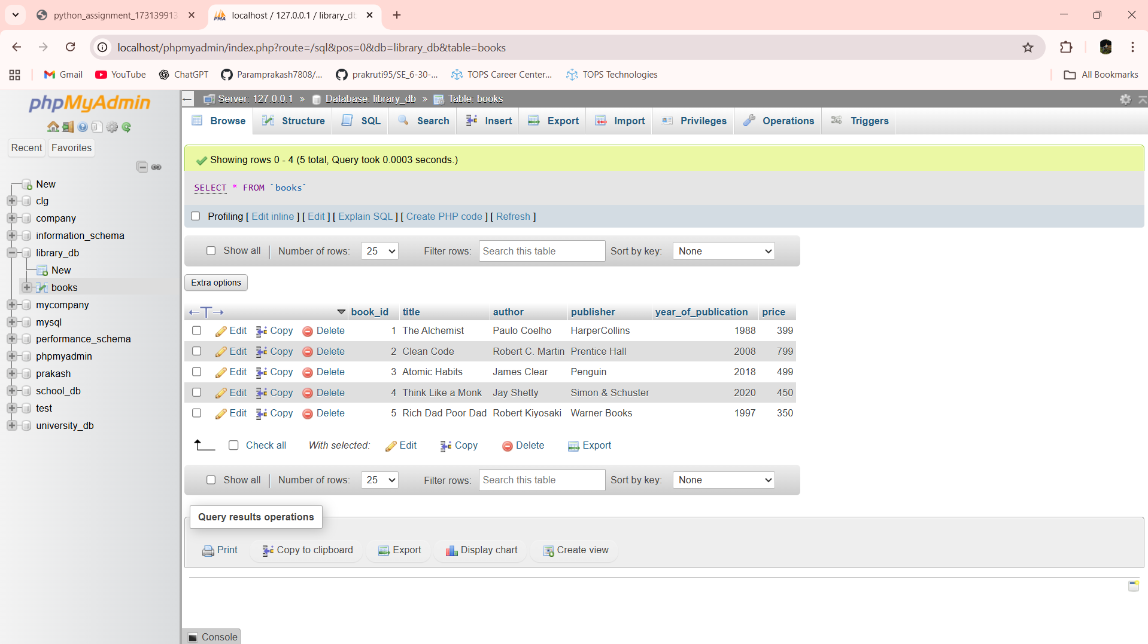

Lab 1.4: Create a table members in library_db with columns: member_id, member_name, date_of_membership, and email. Insert five records into this table.

Ans:- CREATE TABLE members (member_id INT PRIMARY KEY,member_name VARCHAR(100),date_of_membership DATE,email VARCHAR(100))

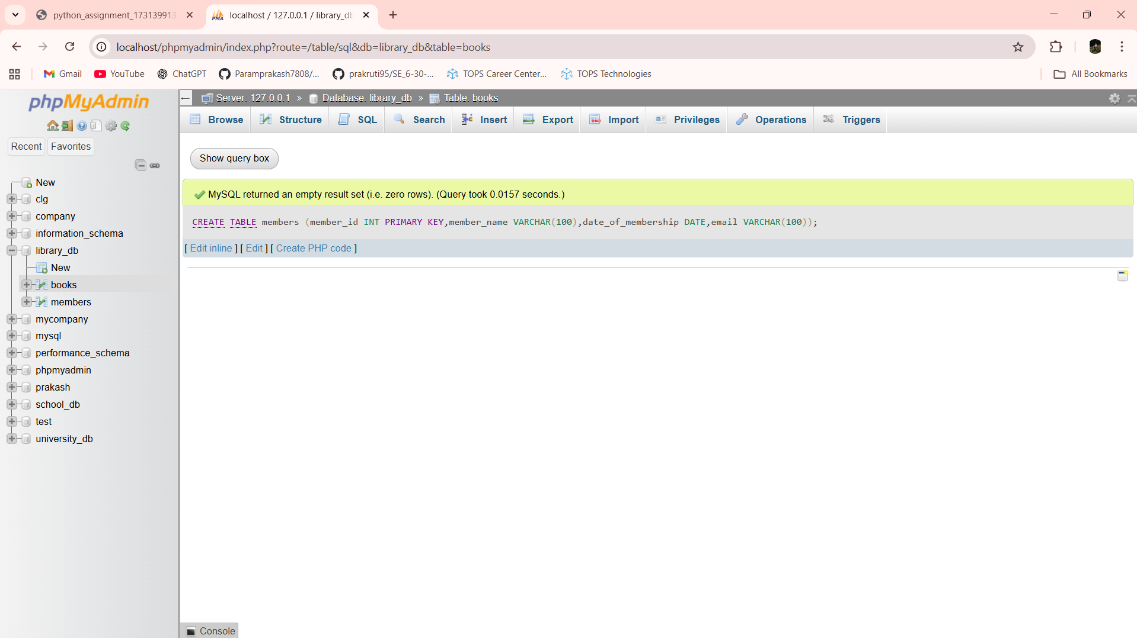

INSERT INTO members VALUES

(1, 'Ajay Makwana', '2023-01-15', 'ajay@gmail.com'),

(2, 'Sahil Makwana', '2023-03-10', 'sahil@gmail.com'),

(3, 'Mayur Makwana', '2023-05-22', 'mayur@gmail.com'),

(4, 'Darshit Makwana', '2023-07-08', 'darshit@gmail.com'),

(5, 'Prakash Makwana', '2023-09-18', 'prakash@gmail.com');

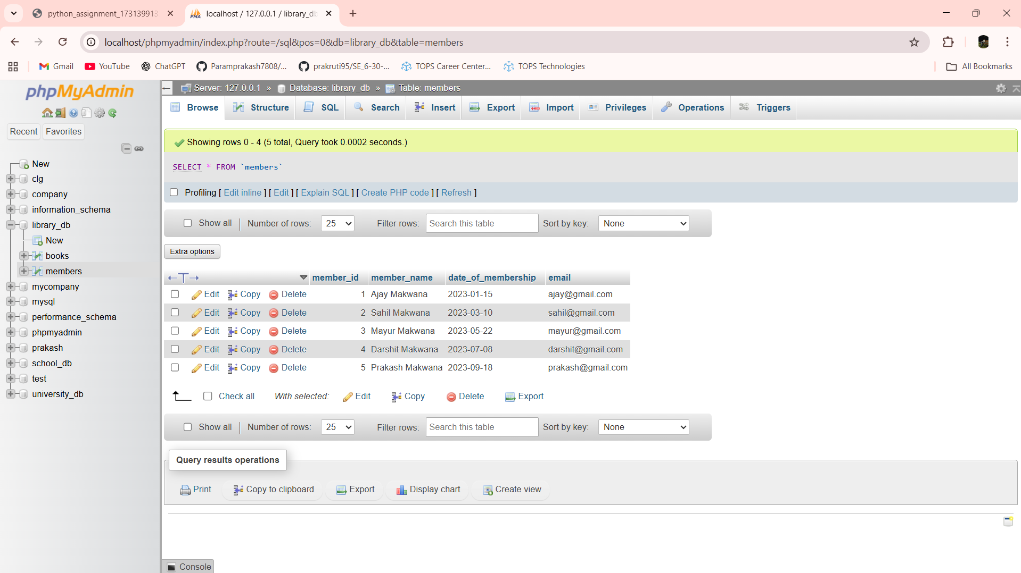

Lab 2.3: Retrieve all members who joined the library before 2022. Use appropriate SQL syntax with WHERE and ORDER BY.

Ans:- SELECT * FROM members WHERE date_of_membership < '2022-01-01' ORDER BY date_of_membership

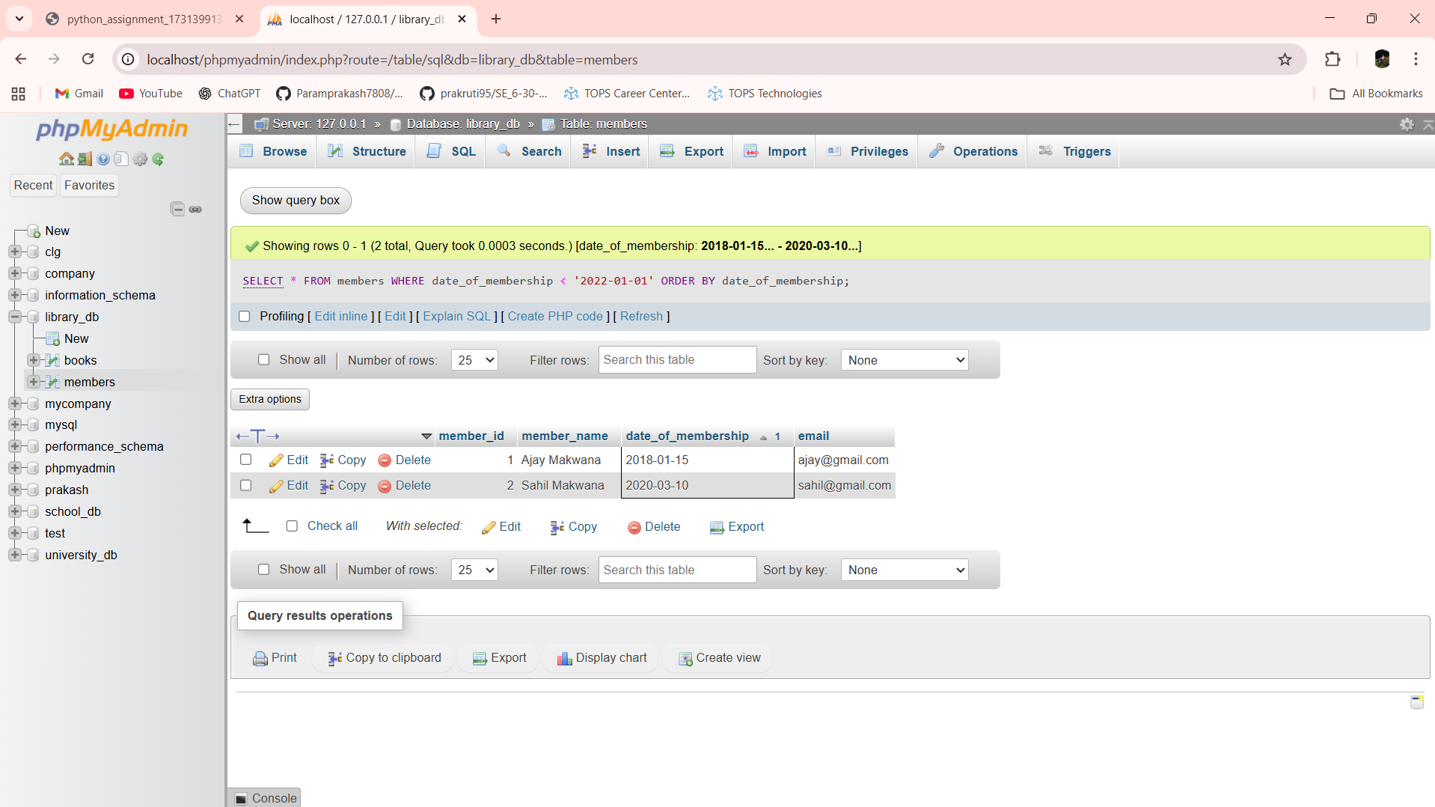

Lab 2.4: Write SQL queries to display the titles of books published by a specific author. Sort the results by year_of_publication in descending order.

Ans:- SELECT title FROM books WHERE author = 'Robert Kiyosaki' ORDER BY year_of_publication DESC

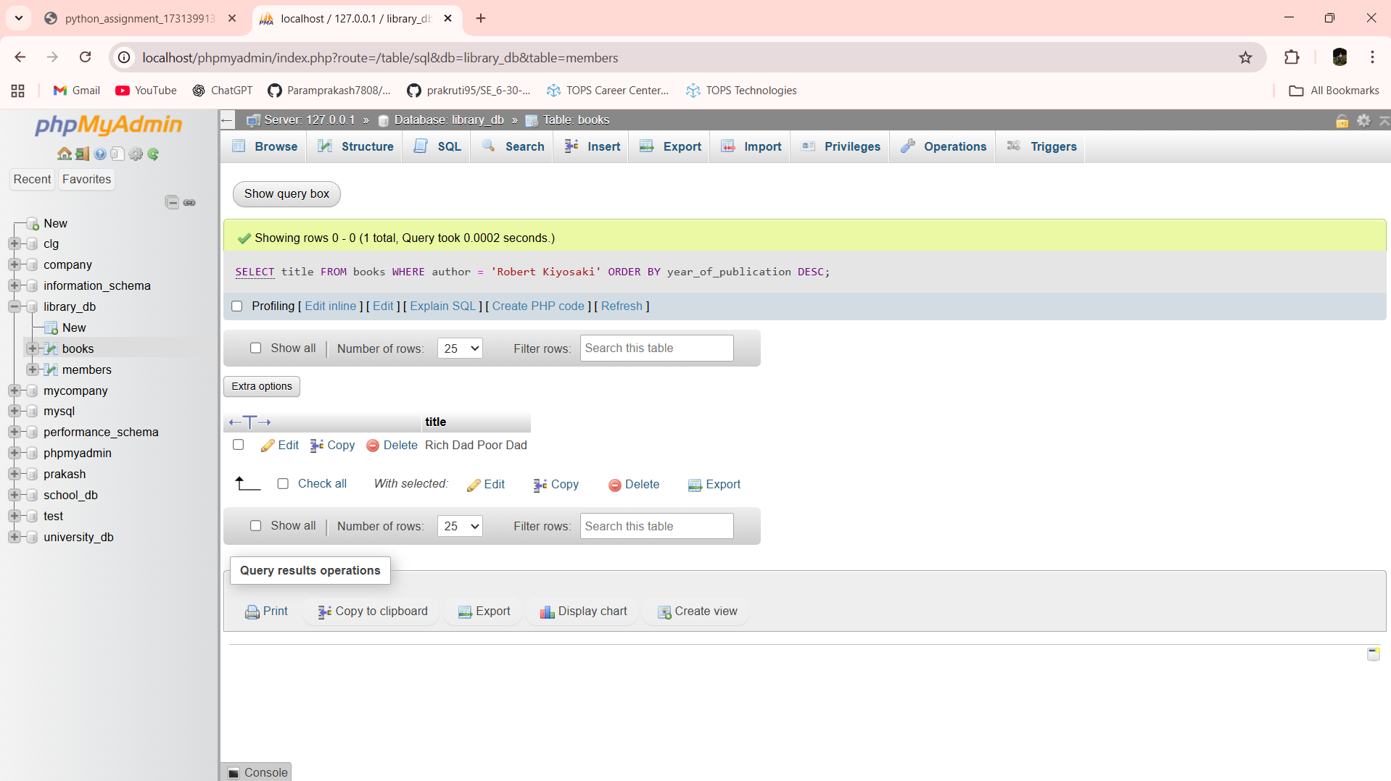

Lab 3.3: Add a CHECK constraint to ensure that the price of books in the books table is greater than 0.

Ans:- ALTER TABLE books ADD CONSTRAINT chk_price CHECK (price > 0)

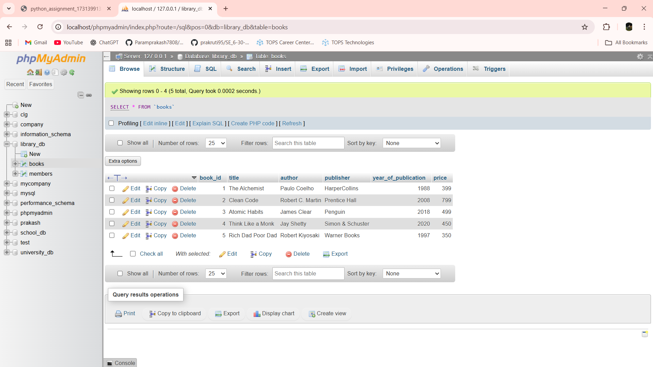

Lab 3.4: Modify the members table to add a UNIQUE constraint on the email column, ensuring that each member has a unique email address.

Ans:- ALTER TABLE members ADD CONSTRAINT uq_email UNIQUE (email)

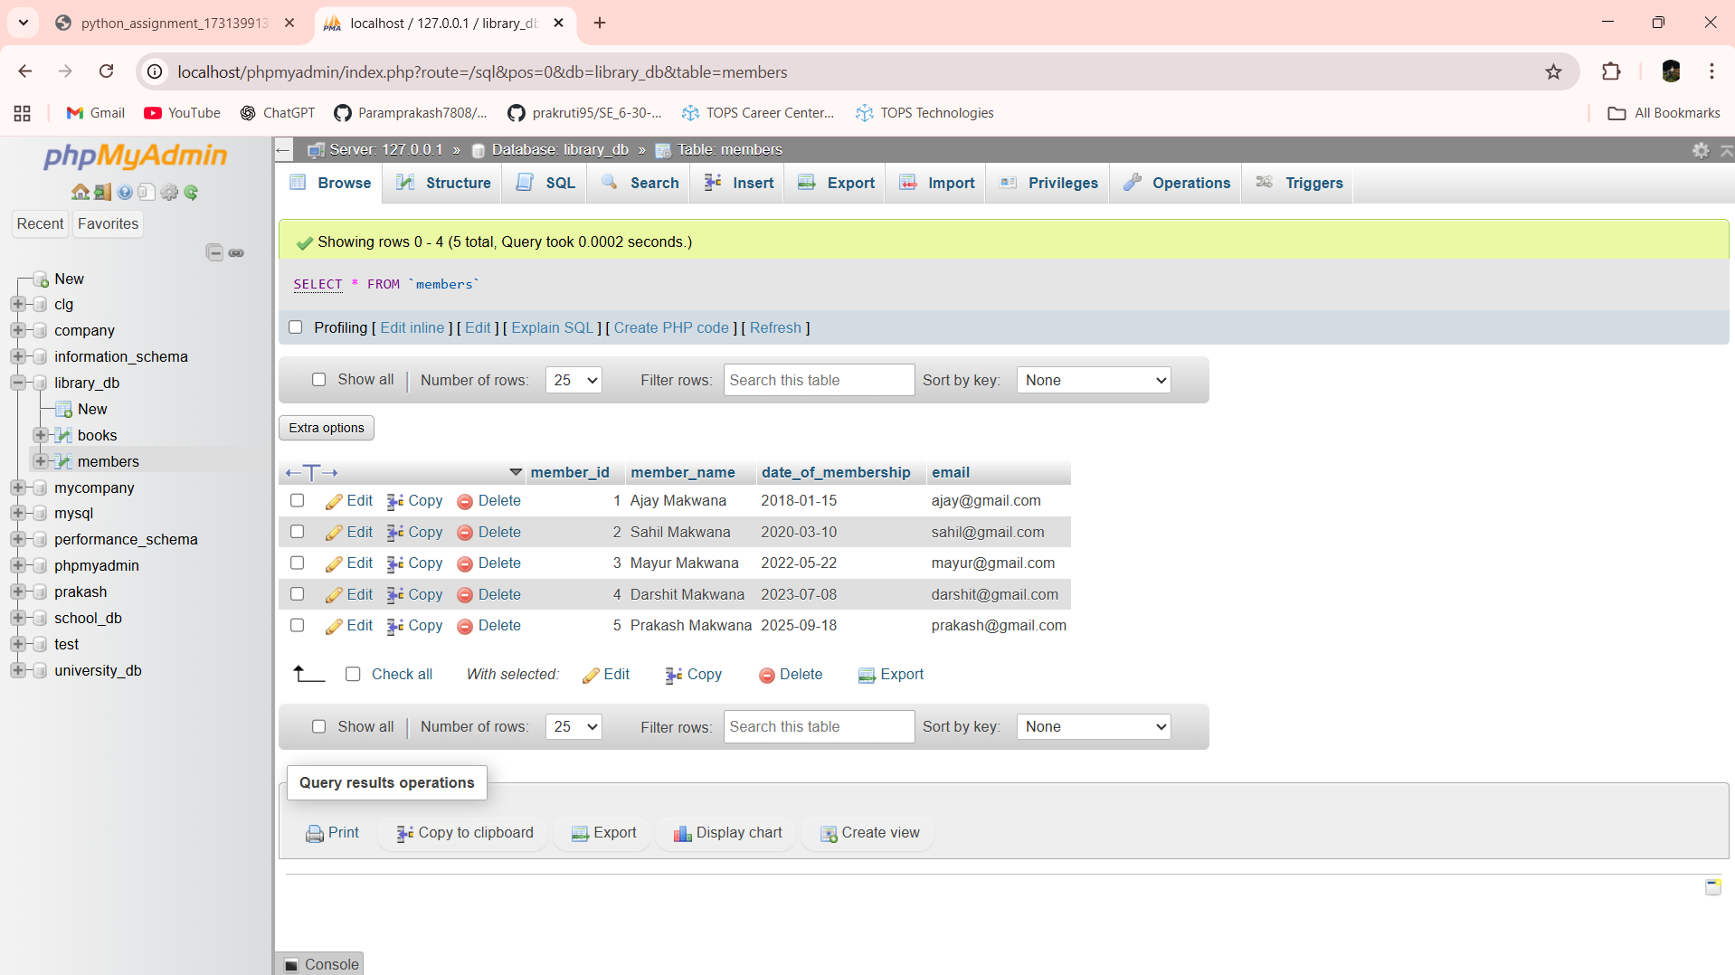

Lab 4.3: Create a table authors with the following columns: author_id, first_name, last_name, and country. Set author_id as the primary key.

Ans:- CREATE TABLE authors (author_id INT PRIMARY KEY,first_name VARCHAR(50),last_name VARCHAR(50),country VARCHAR(50))

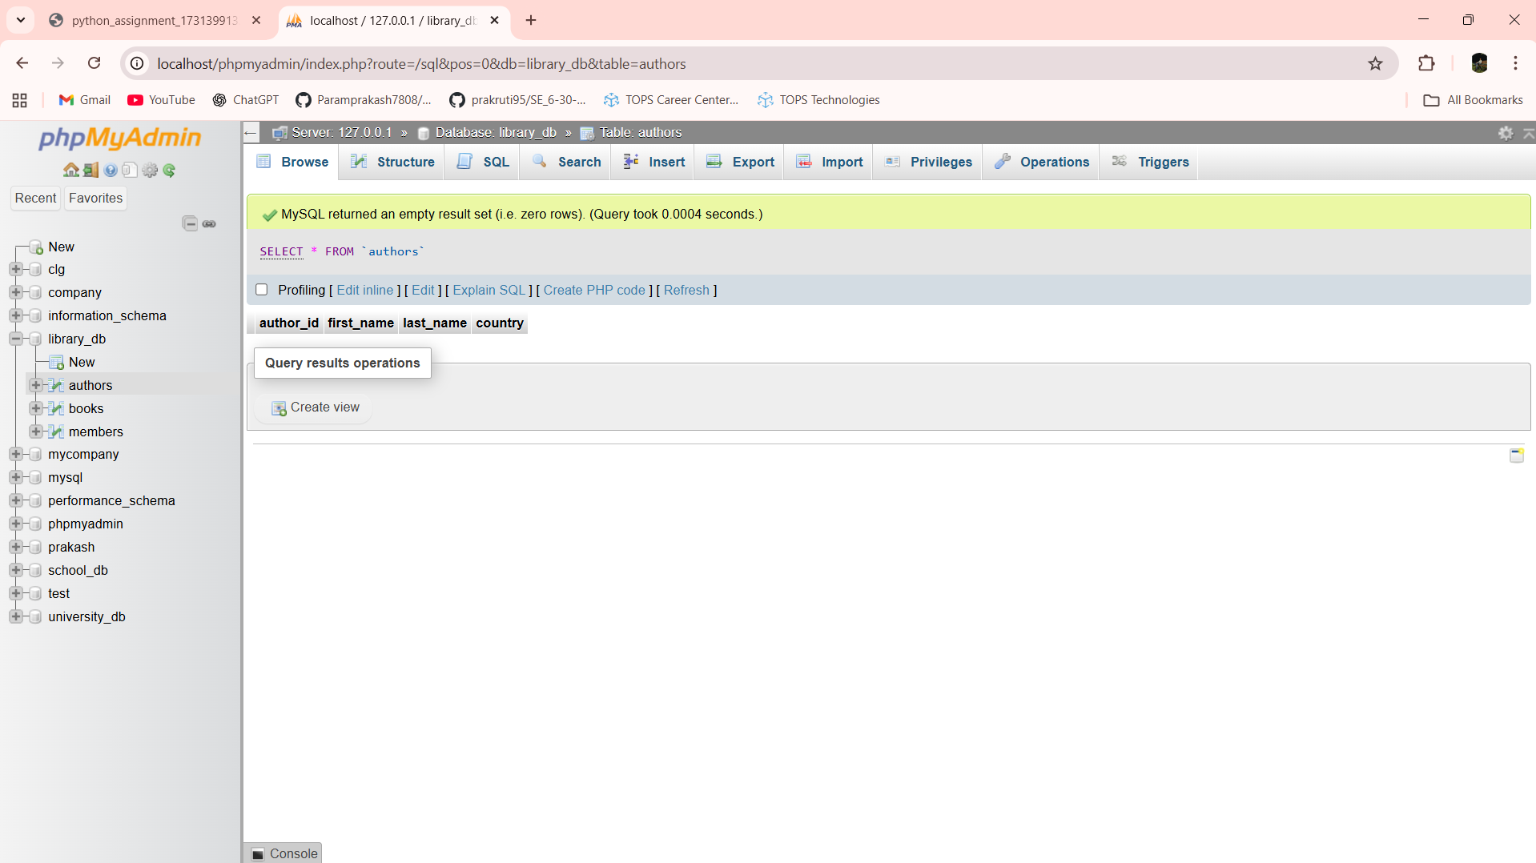

Lab 4.4: Create a table publishers with columns: publisher_id, publisher_name, contact_number, and address. Set publisher_id as the primary key and contact_number as unique.

Ans:- CREATE TABLE publishers (publisher_id INT PRIMARY KEY,publisher_name VARCHAR(100),contact_number VARCHAR(15) UNIQUE,address VARCHAR(150))

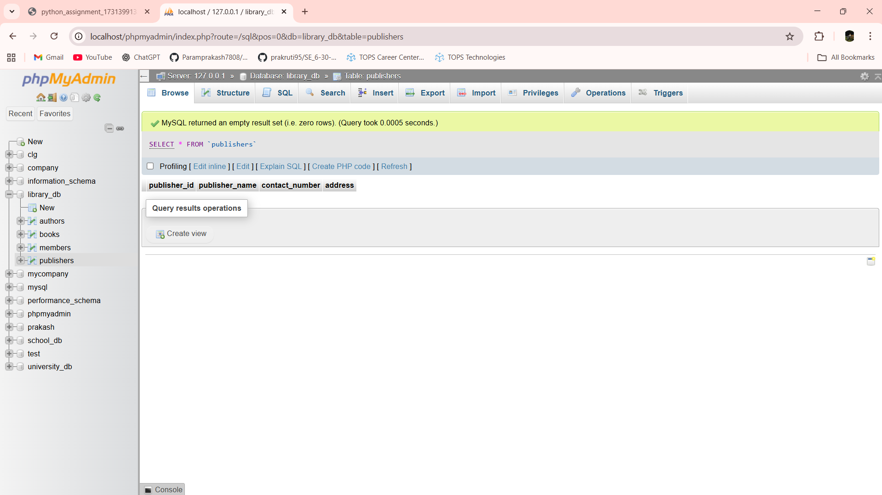

Lab 5.3: Add a new column genre to the books table. Update the genre for all existing records.

Ans:- ALTER TABLE books ADD genre VARCHAR(50)

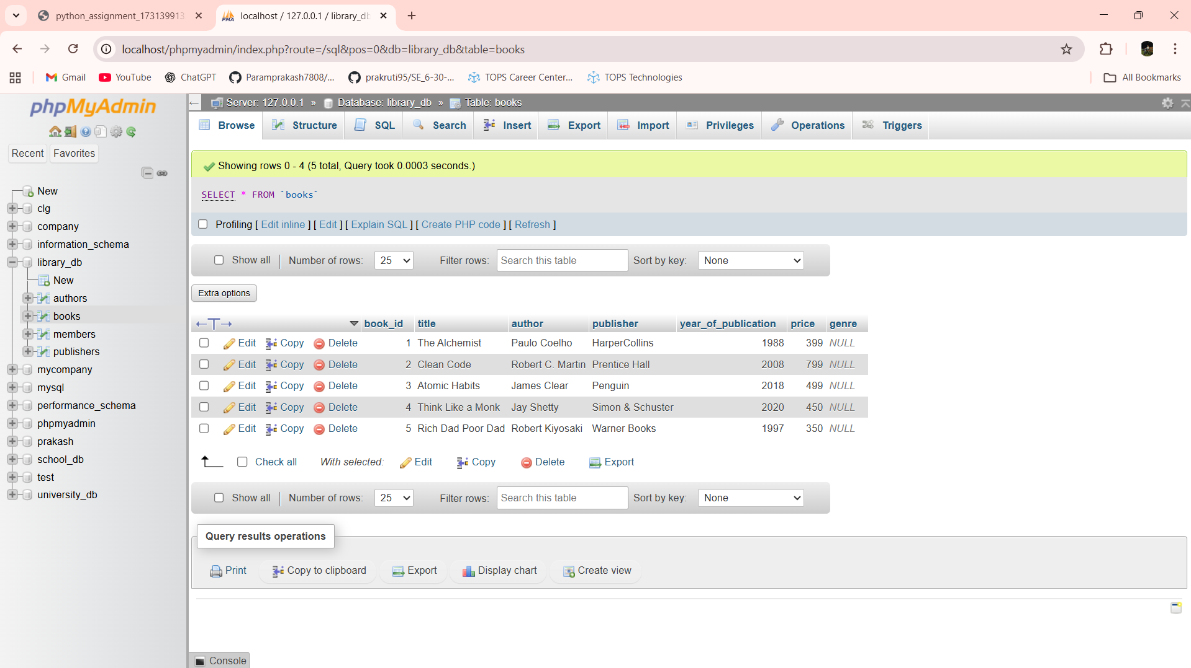

UPDATE books SET genre = 'Fiction'

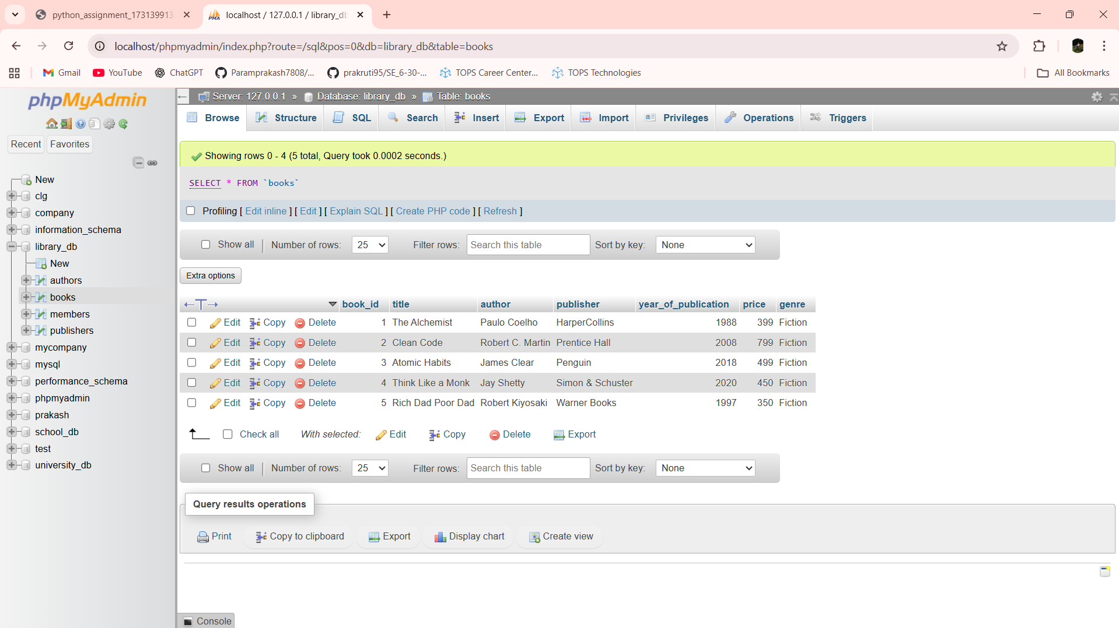

Lab 5.4: Modify the members table to increase the length of the email column to 100 characters.

Ans:- ALTER TABLE members MODIFY email VARCHAR(100)

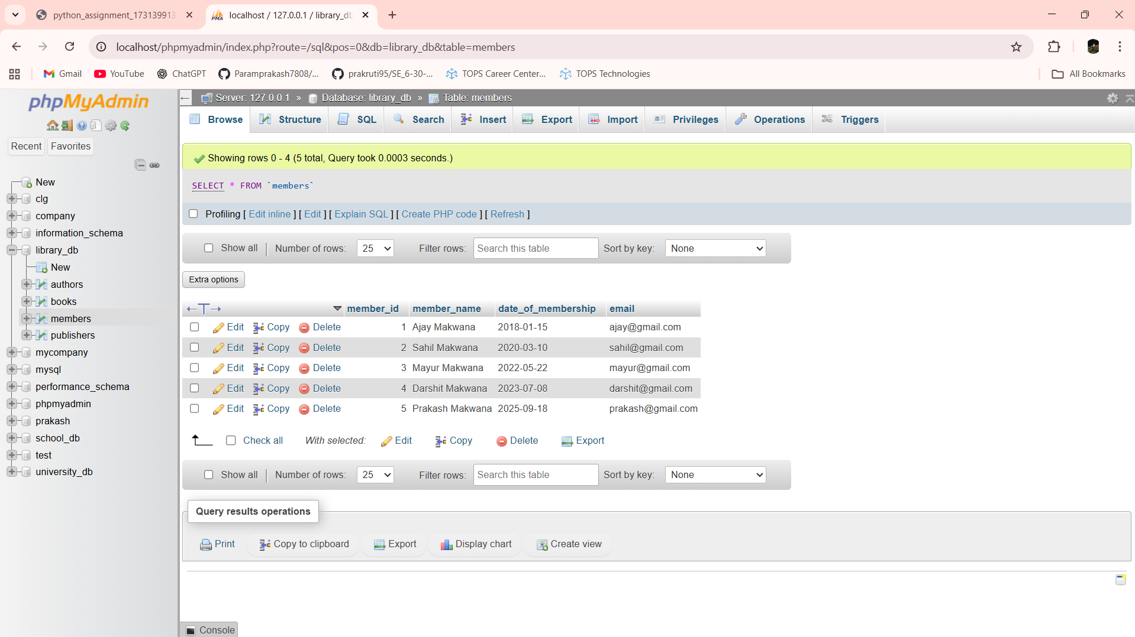

Lab 6.3: Drop the publishers table from the database after verifying its structure.

Ans:-

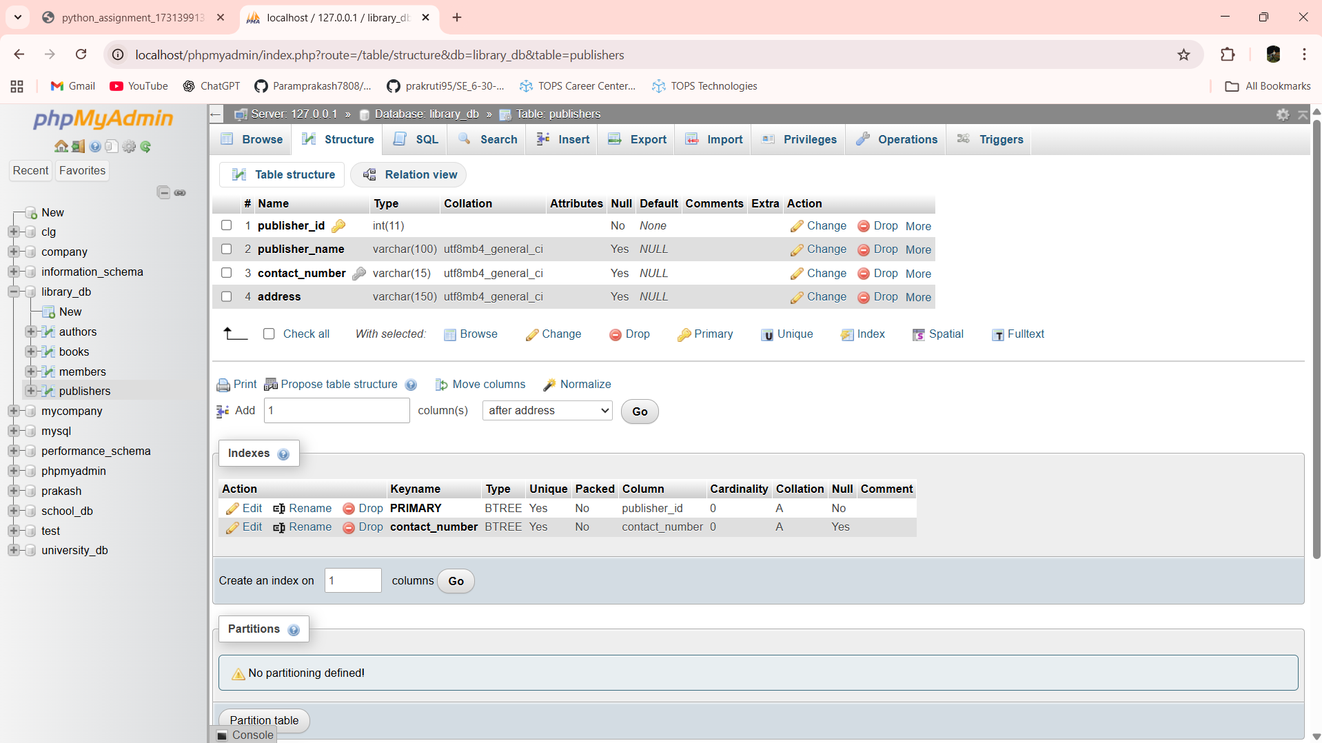

DROP TABLE publishers

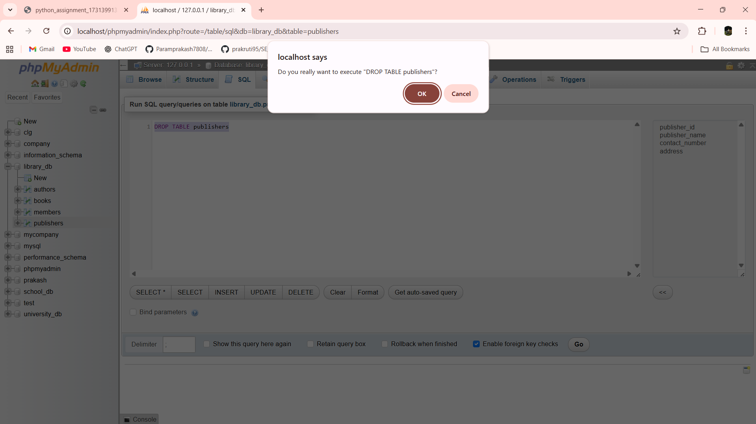

Lab 6.4: Create a backup of the members table and then drop the original members table.

Ans:- CREATE TABLE members_backup AS SELECT * FROM members

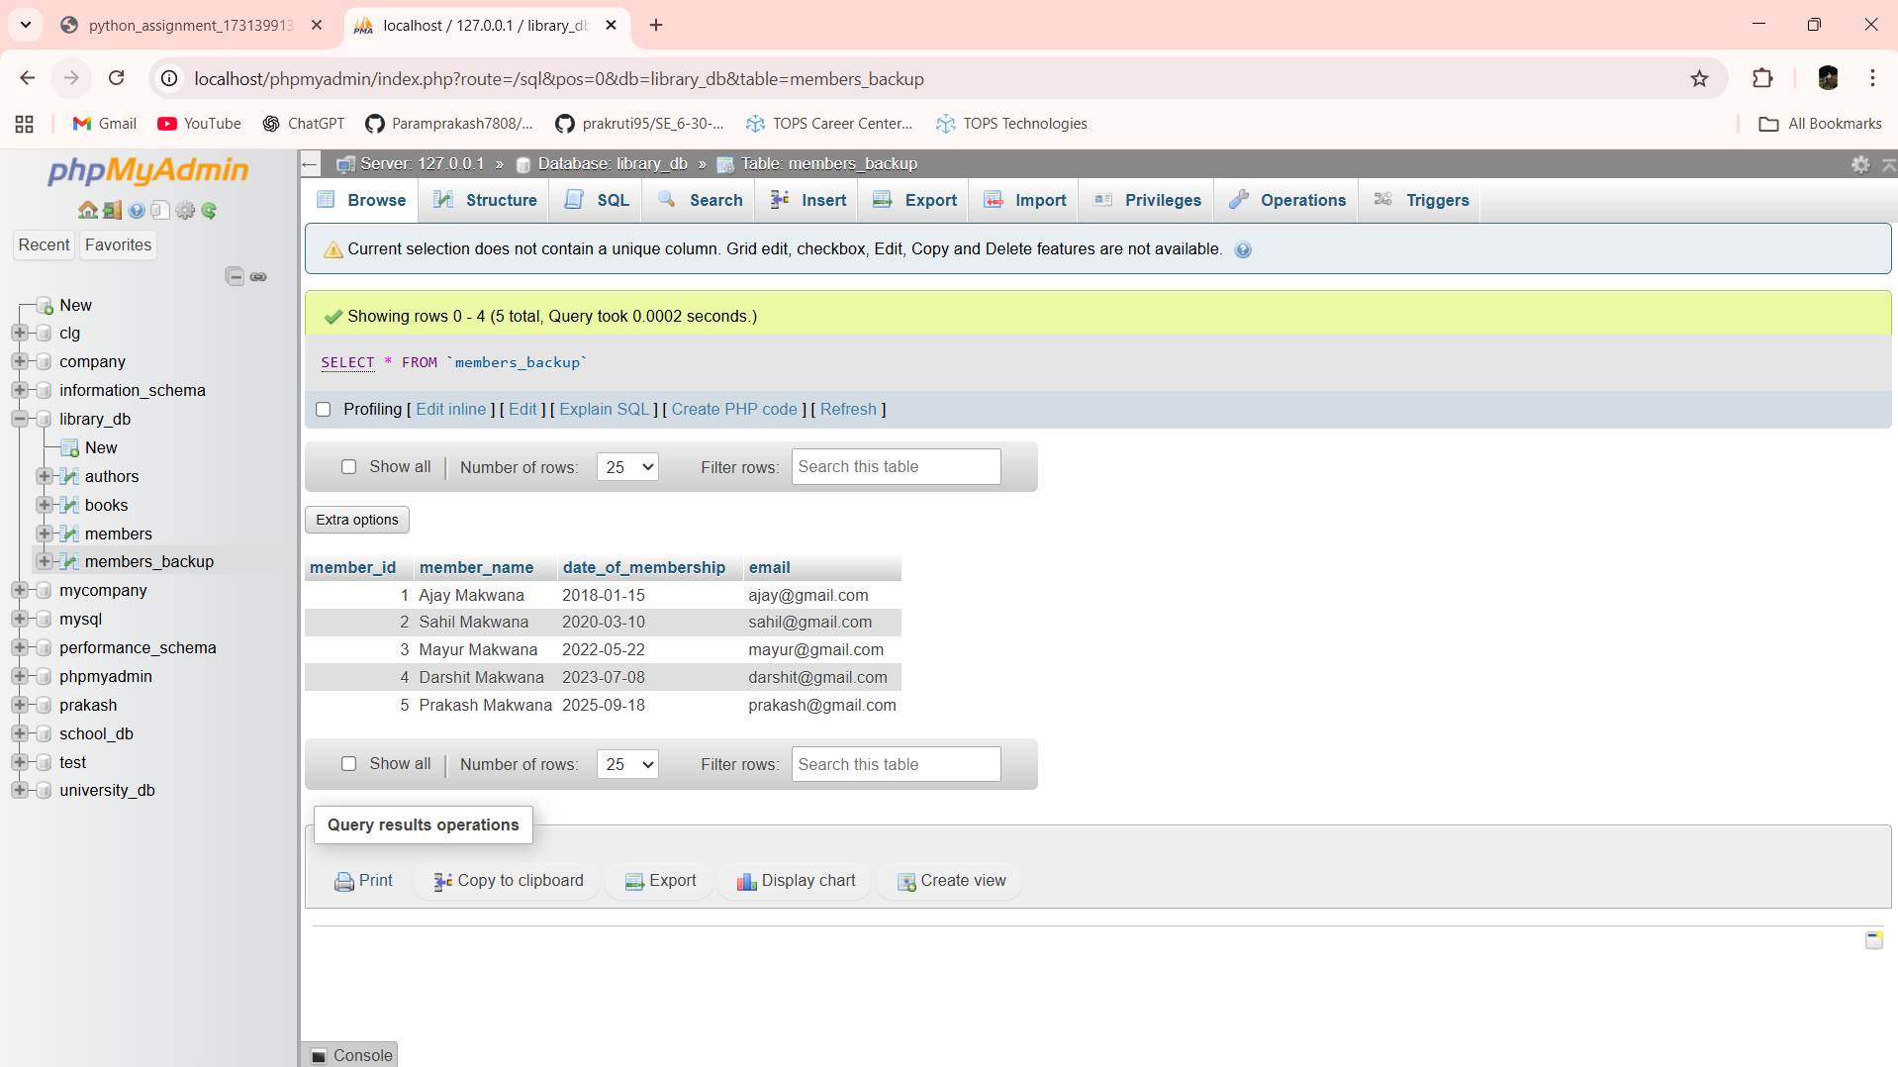

DROP TABLE members

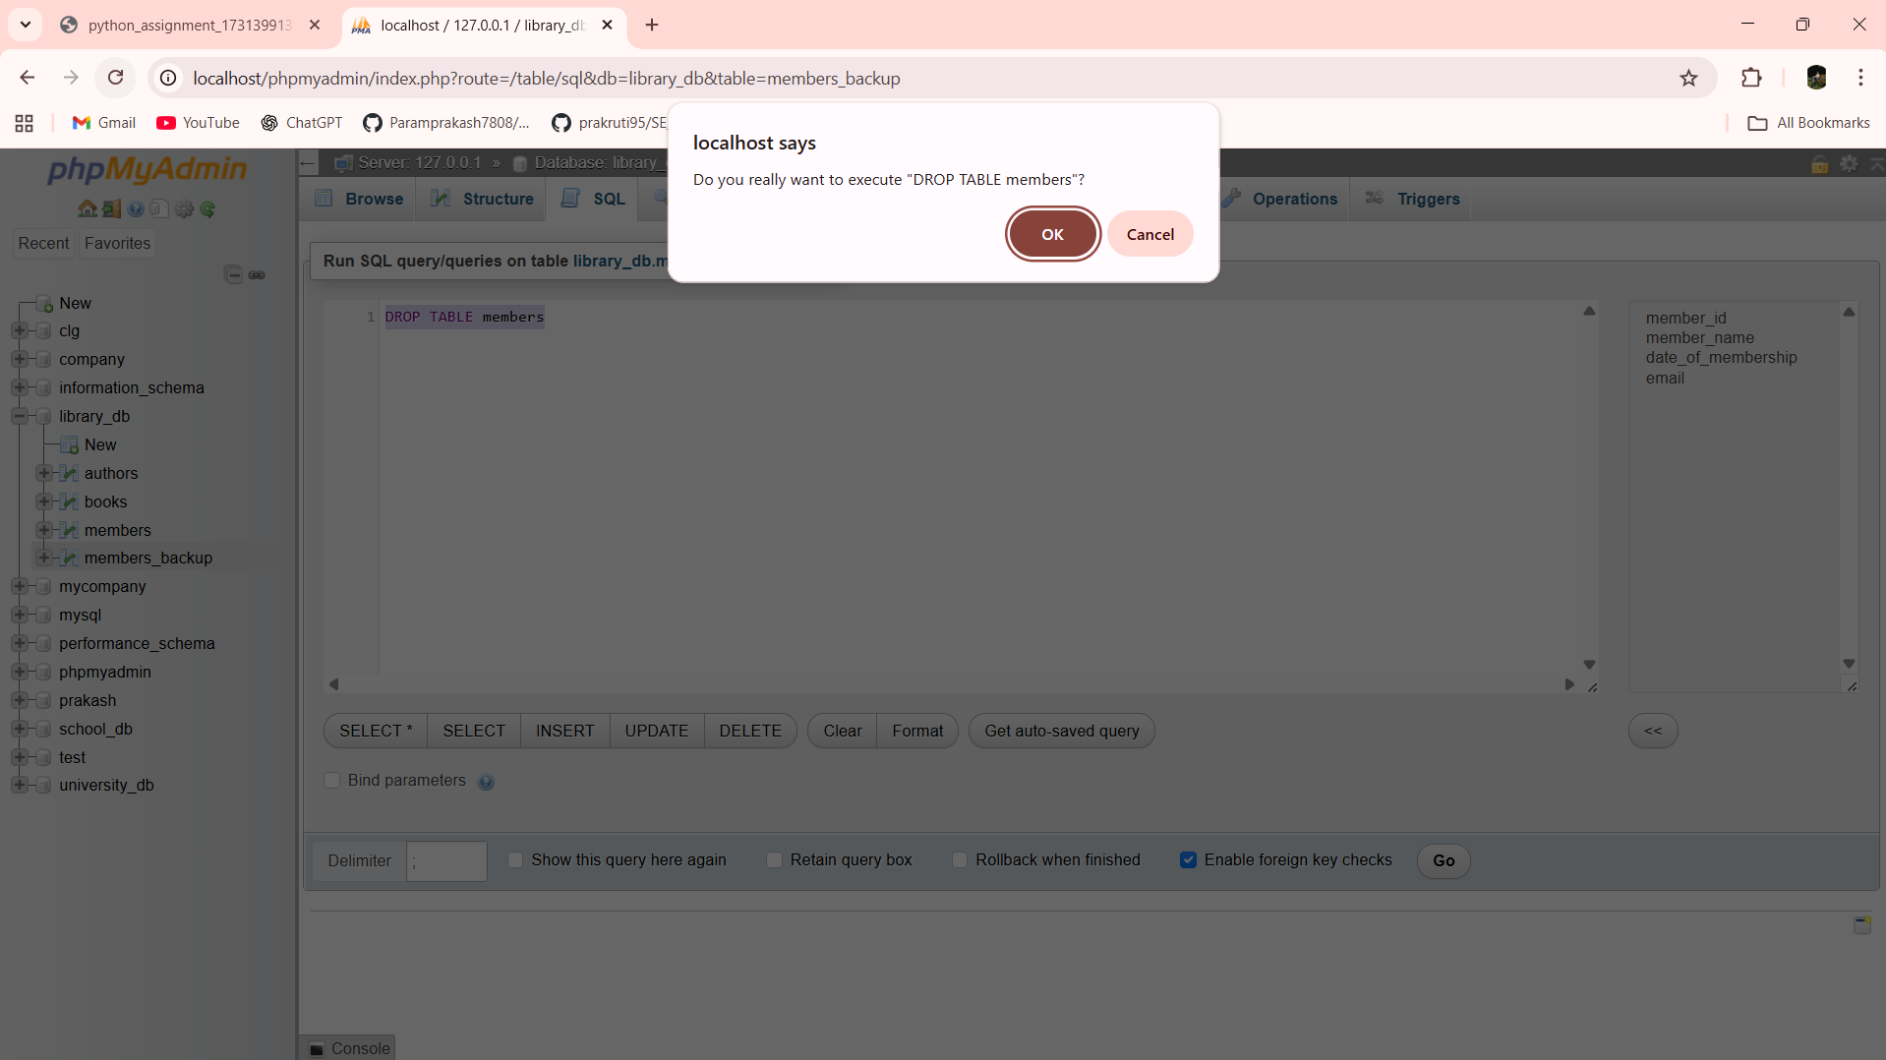

Lab 7.4: Insert three new authors into the authors table, then update the last name of one of the authors.

Ans:- INSERT INTO authors VALUES

(1, 'George', 'Orwell', 'UK'),

(2, 'Jane', 'Austen', 'UK'),

(3, 'Mark', 'Twain', 'USA')

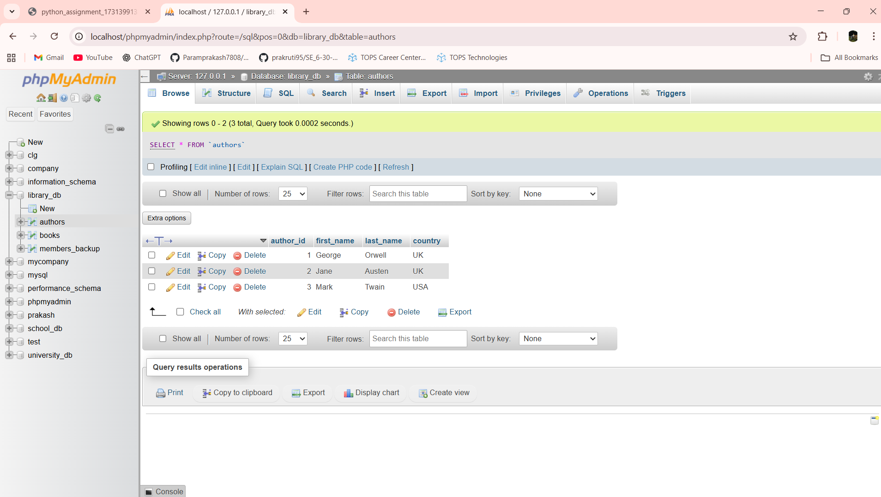

UPDATE authors SET last_name = 'Austin' WHERE author_id = 2

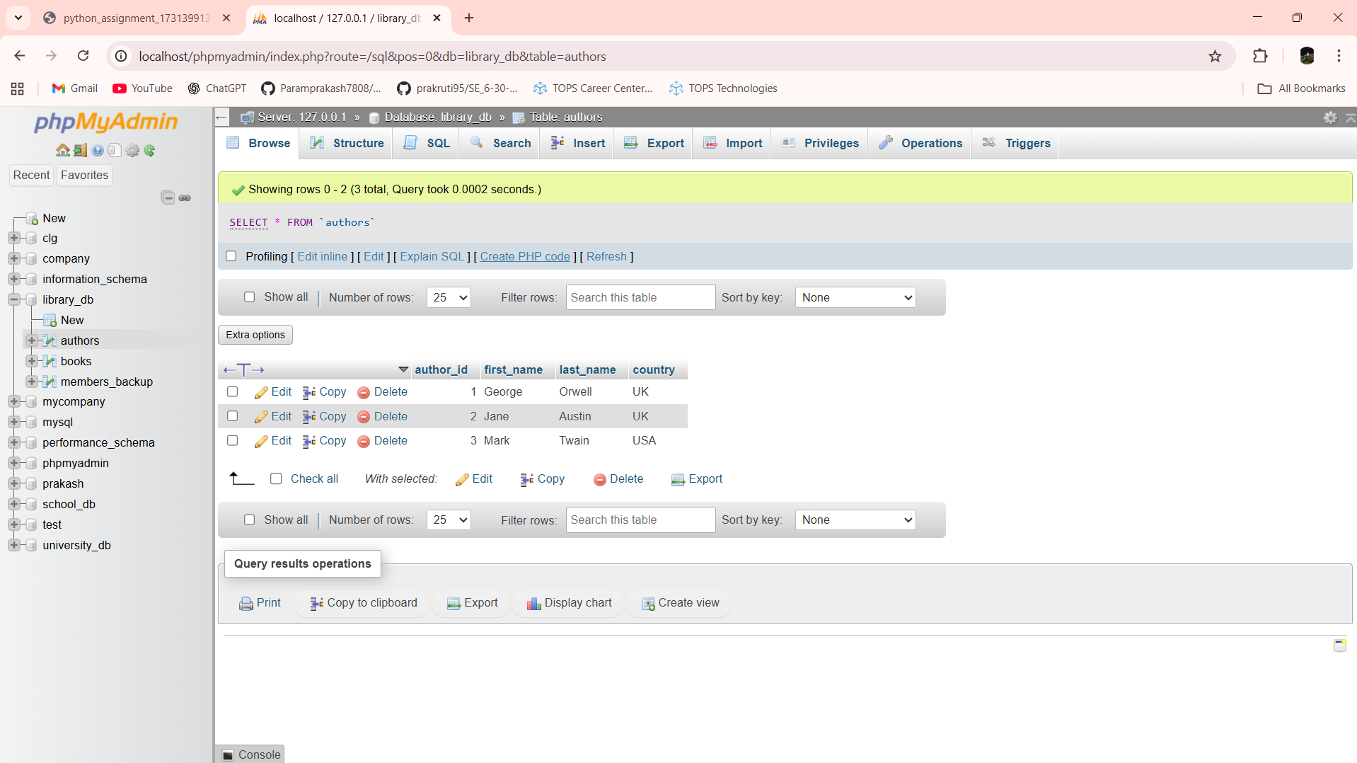

Lab 7.5: Delete a book from the books table where the price is higher than $100.

Ans:- 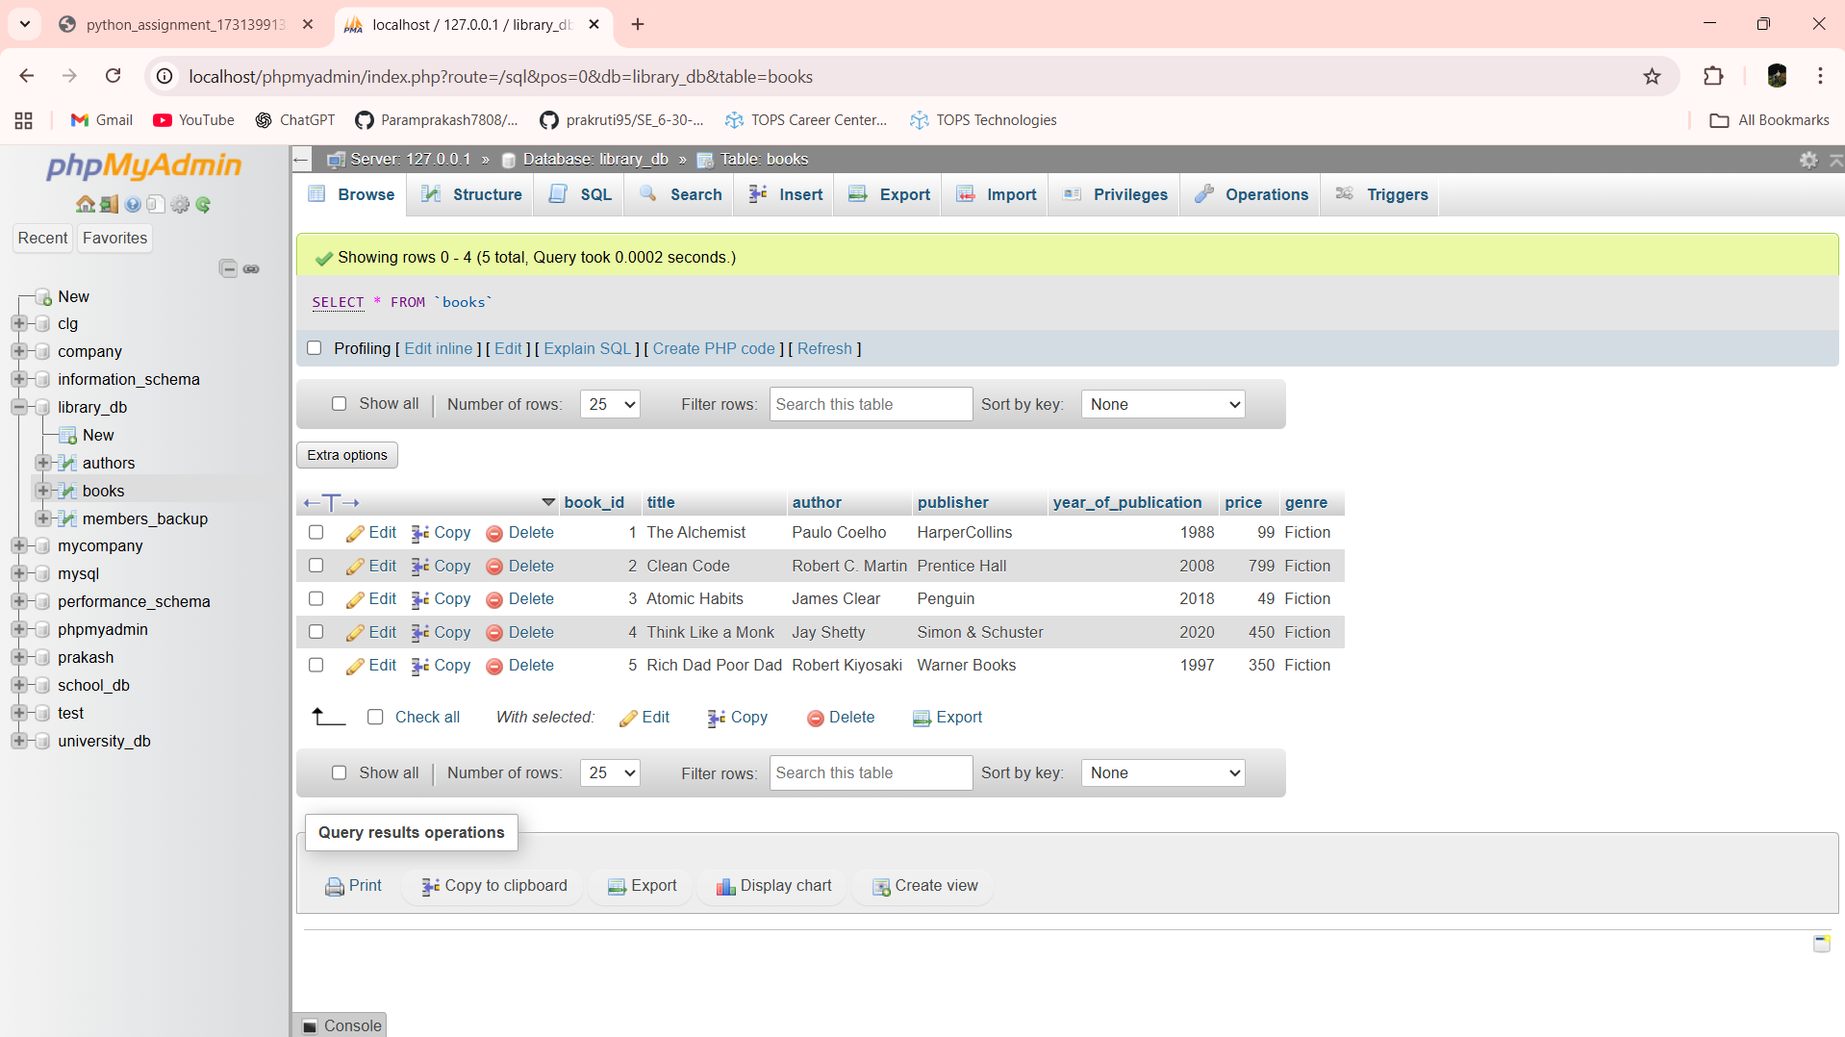

DELETE FROM books WHERE price > 100

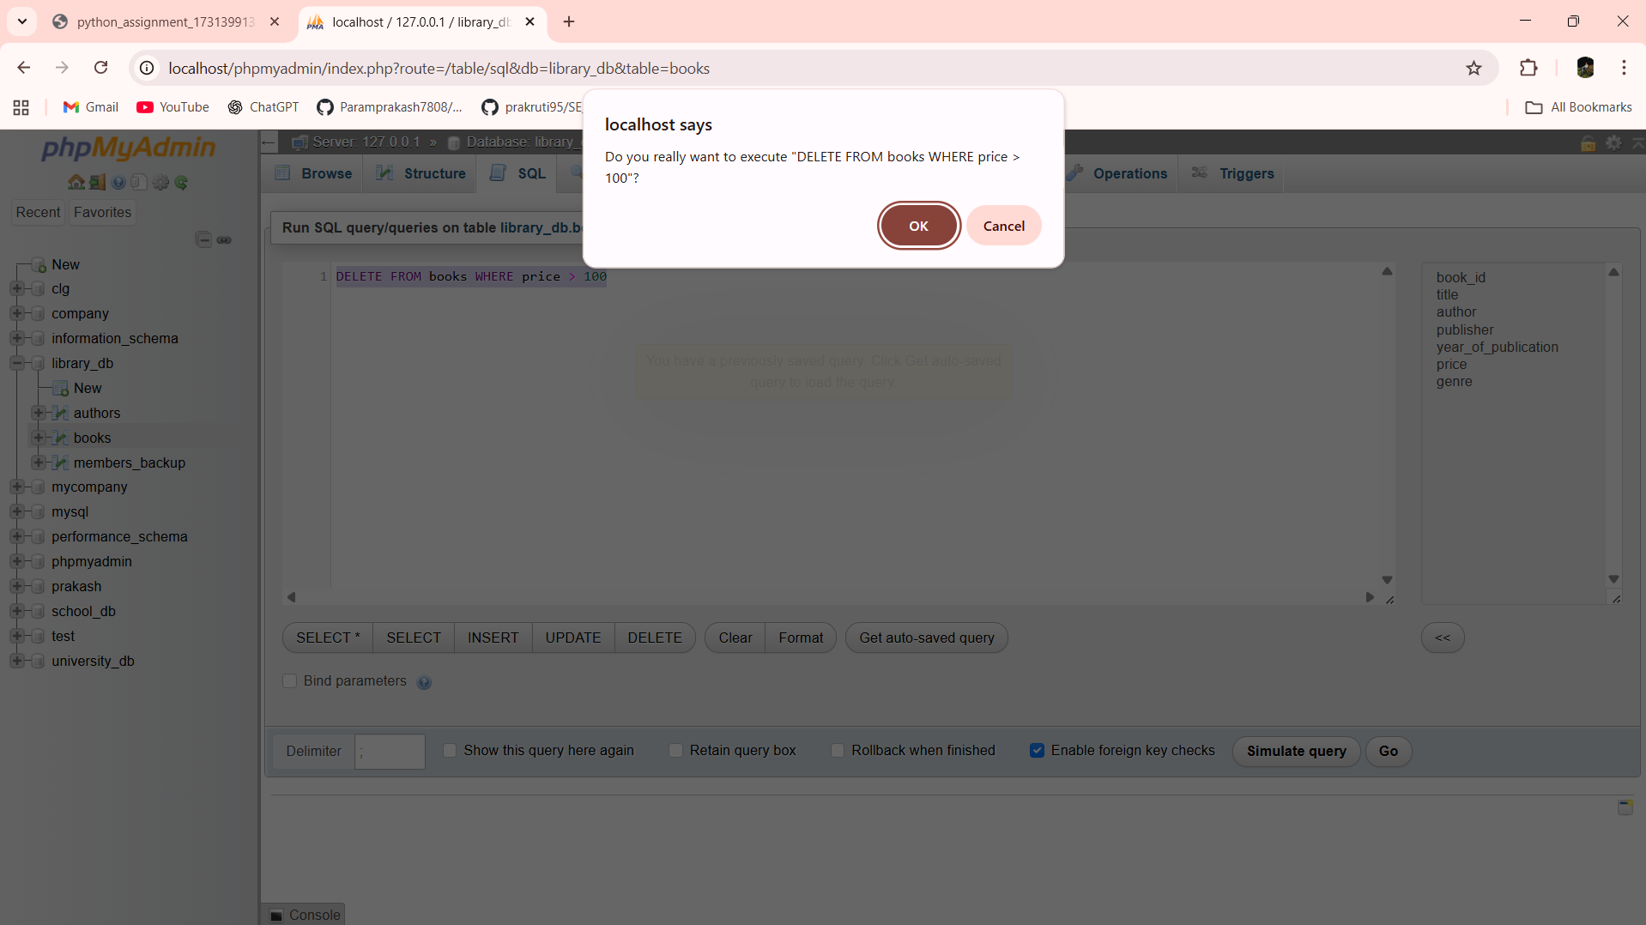

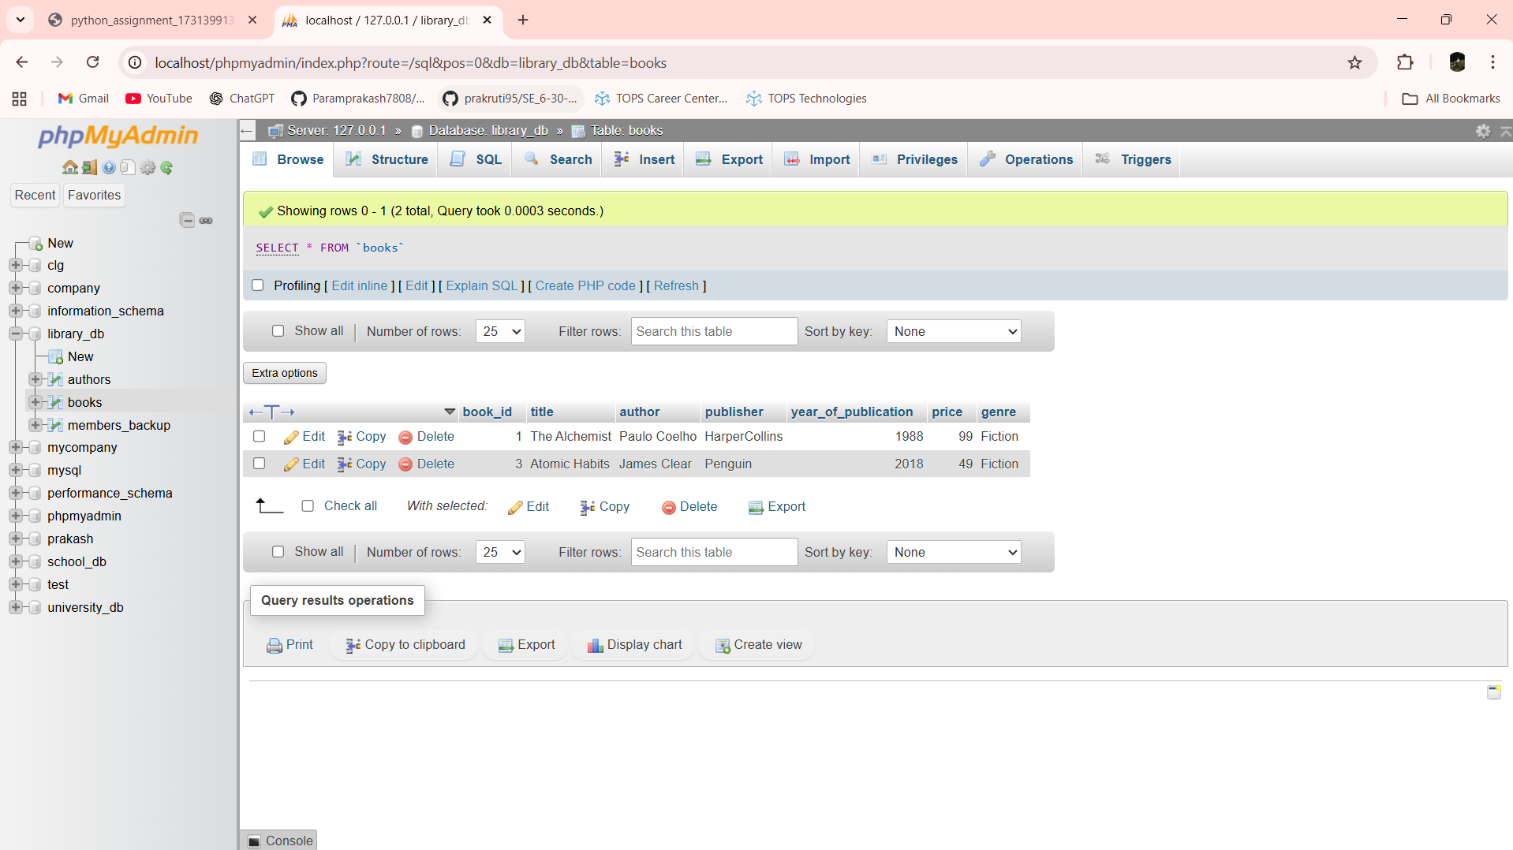

Lab 8.3: Update the year_of_publication of a book with a specific book_id.

Ans:- 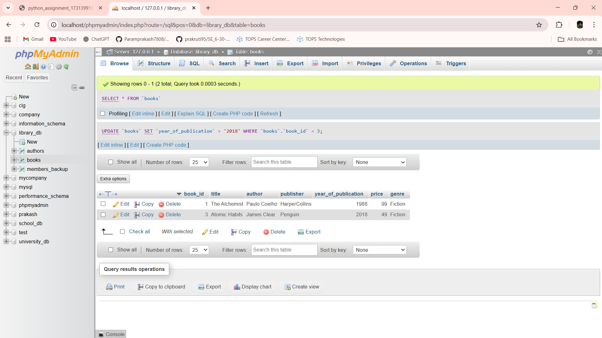

UPDATE books SET year_of_publication = 2021 WHERE book_id = 3

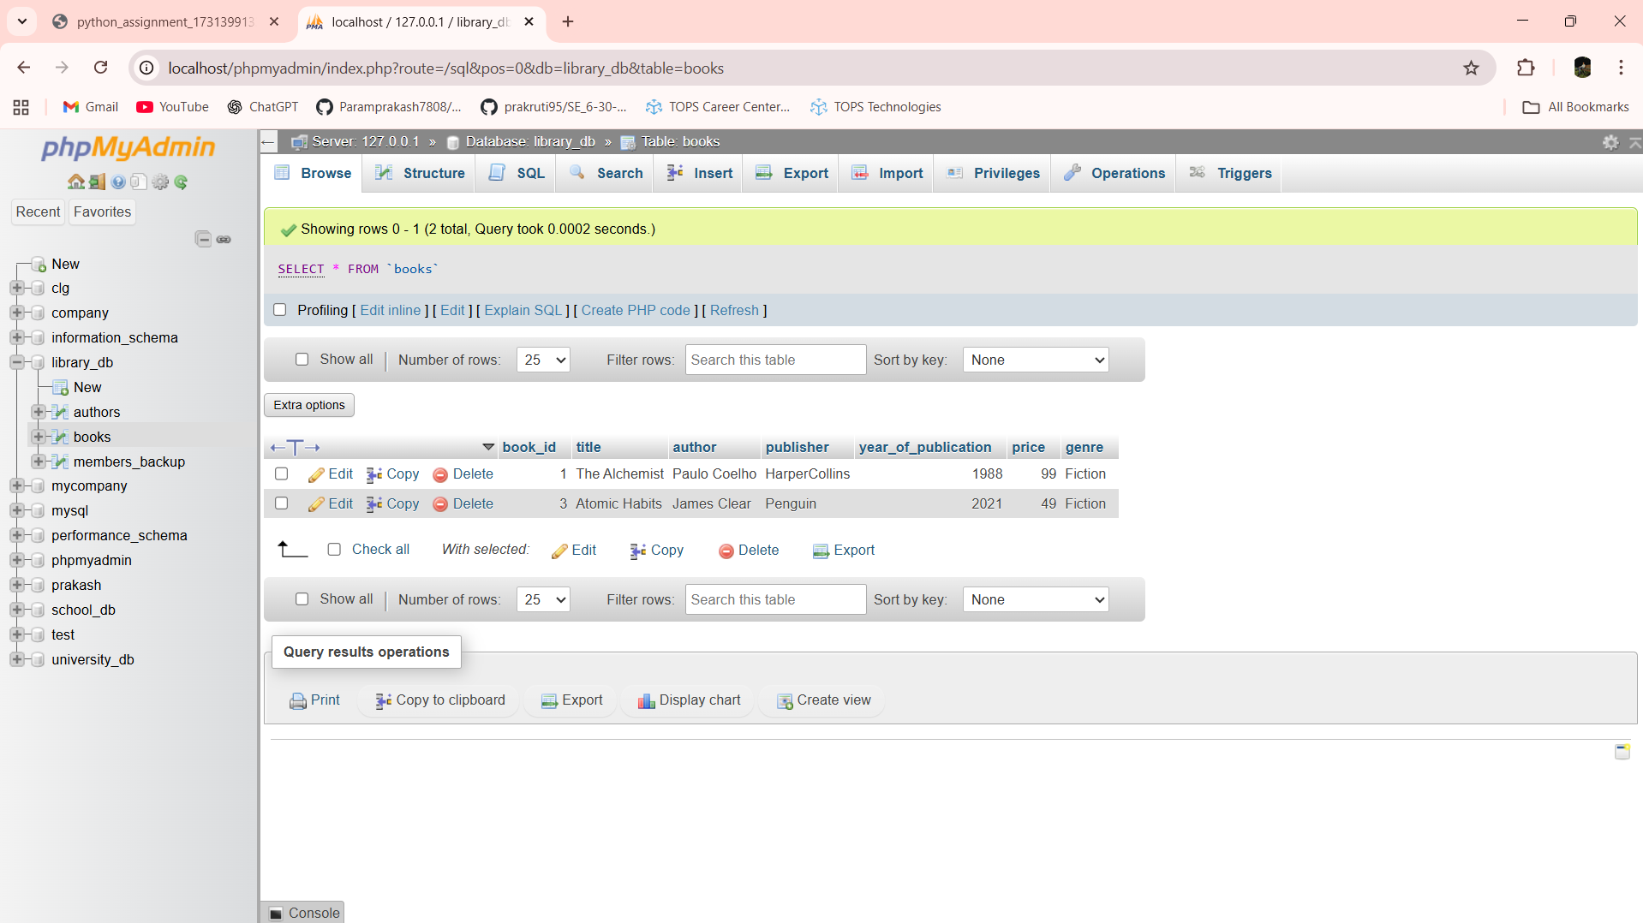

Lab 8.4: Increase the price of all books published before 2015 by 10%.

Ans:- 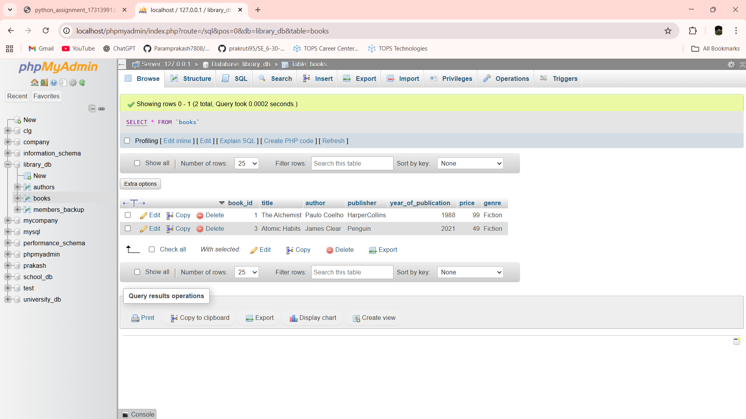

UPDATE books SET price = price + (price * 0.10) WHERE year_of_publication < 2015

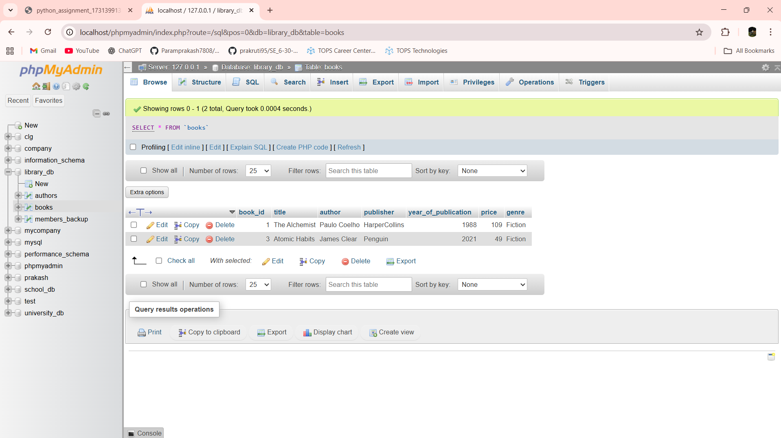

Lab 9.3: Remove all members who joined before 2020 from the members table.

Ans:- 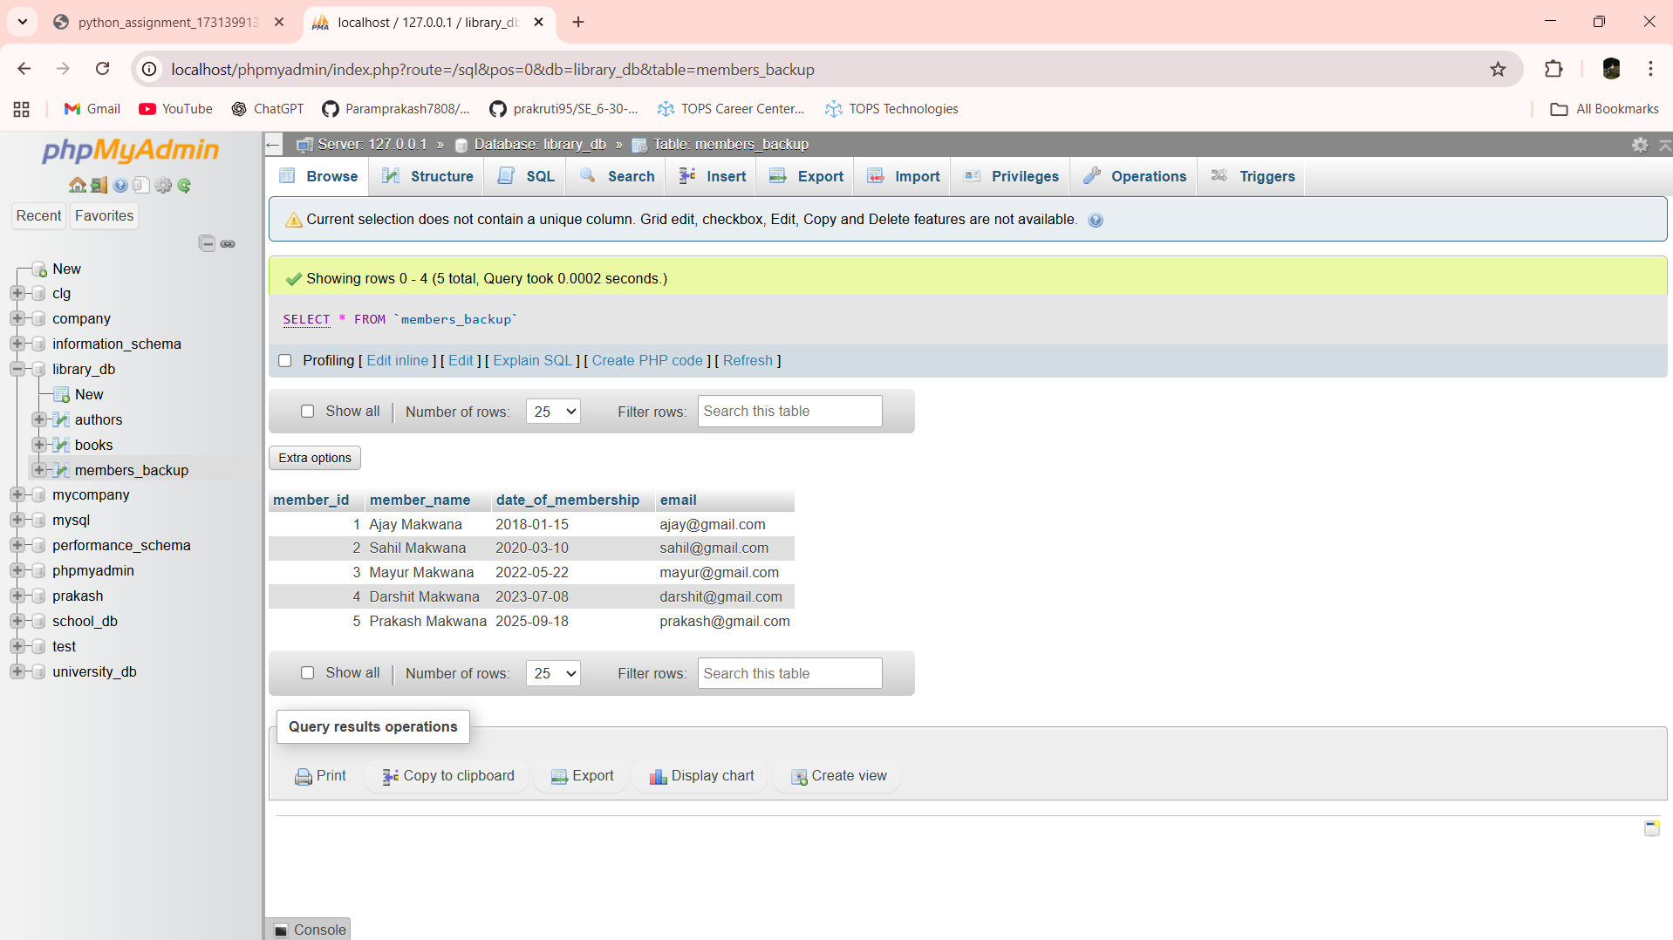

DELETE FROM members_backup WHERE date_of_membership < '2020-01-01'

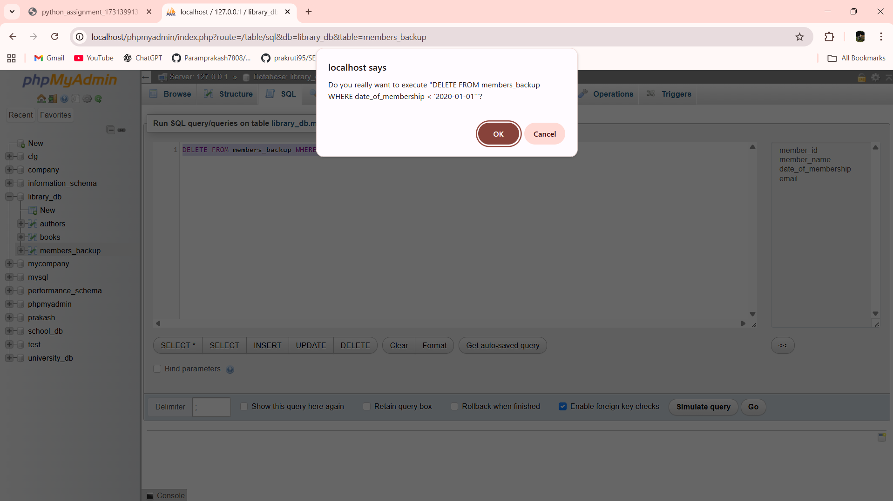

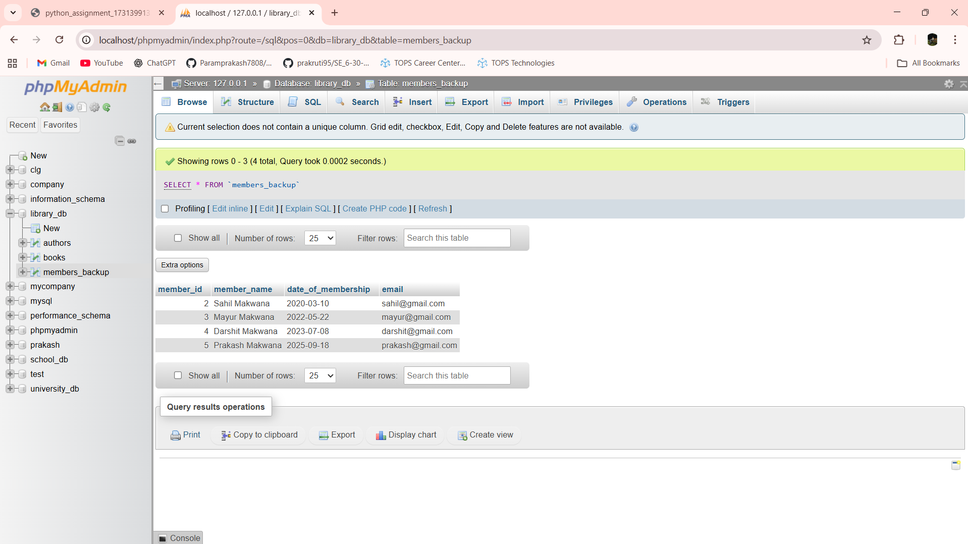

Lab 9.4: Delete all books that have a NULL value in the author column.

Ans:-

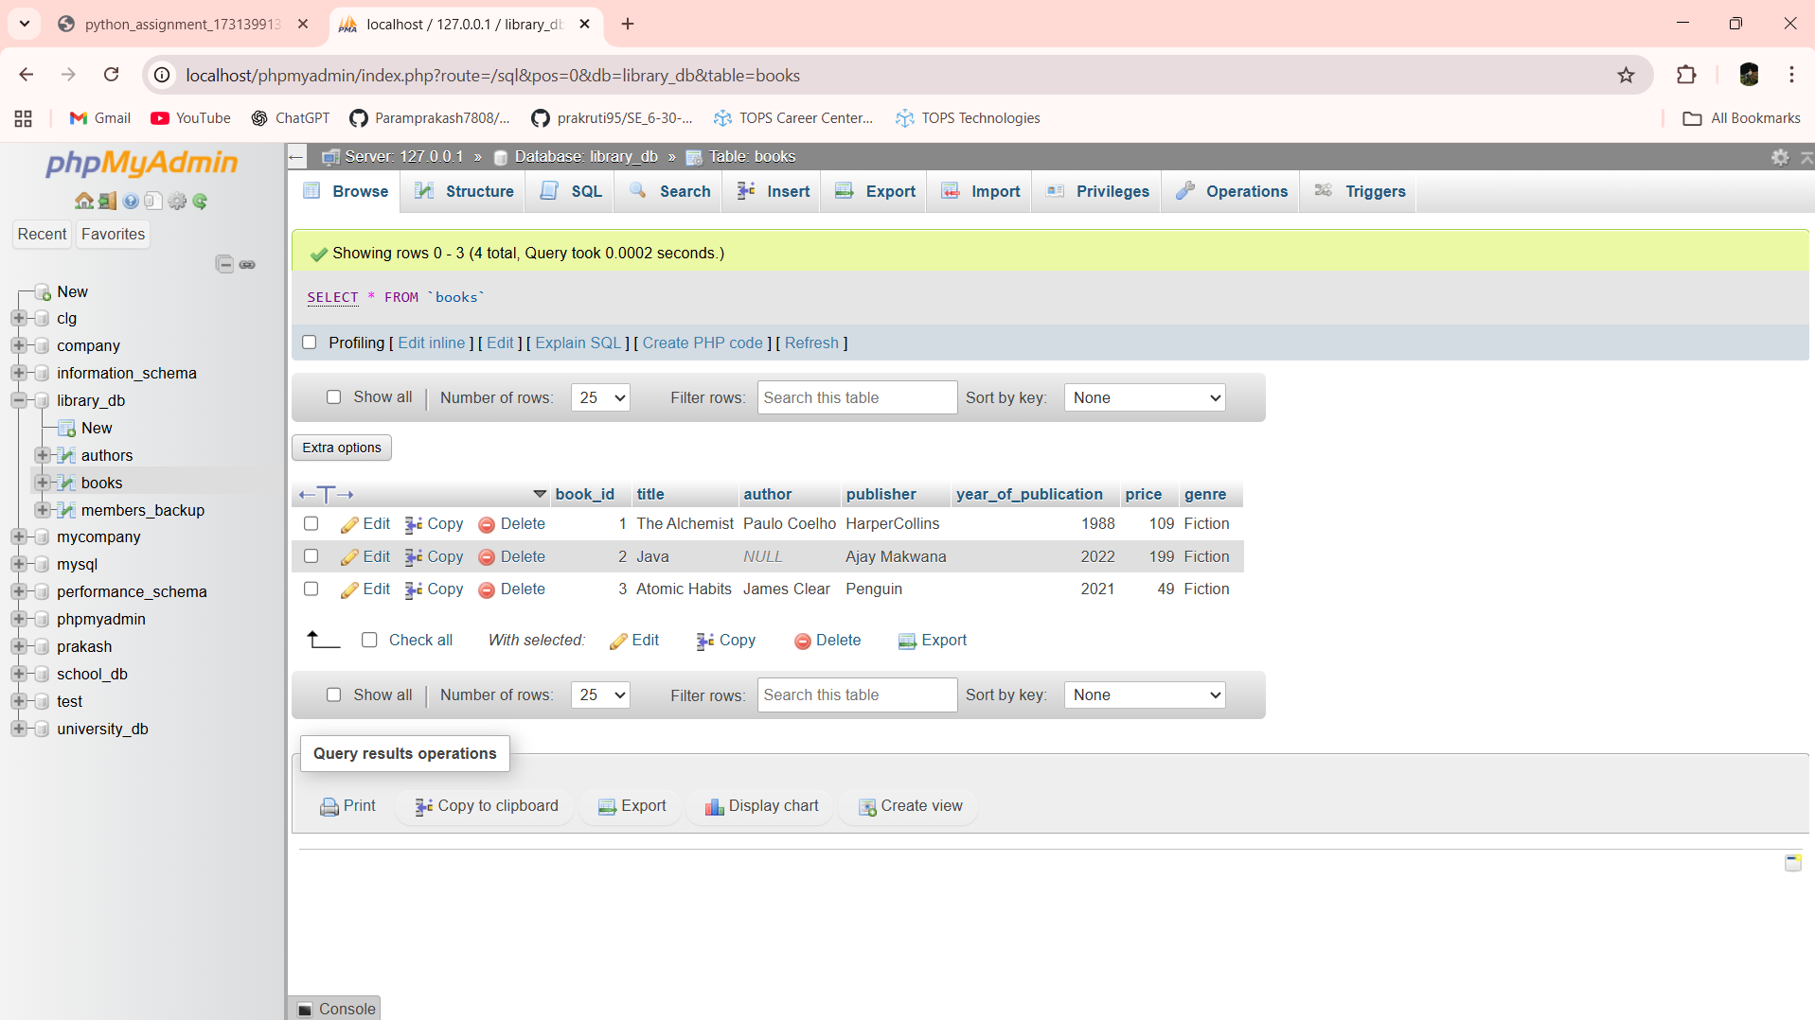

DELETE FROM books WHERE author IS NULL

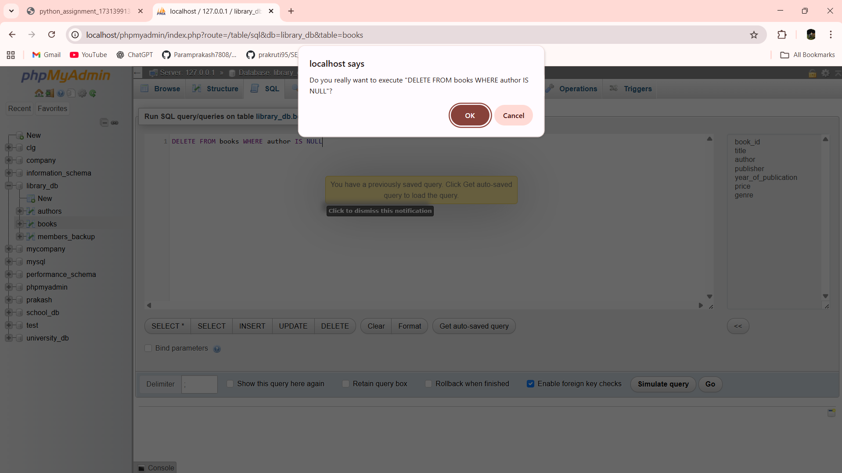

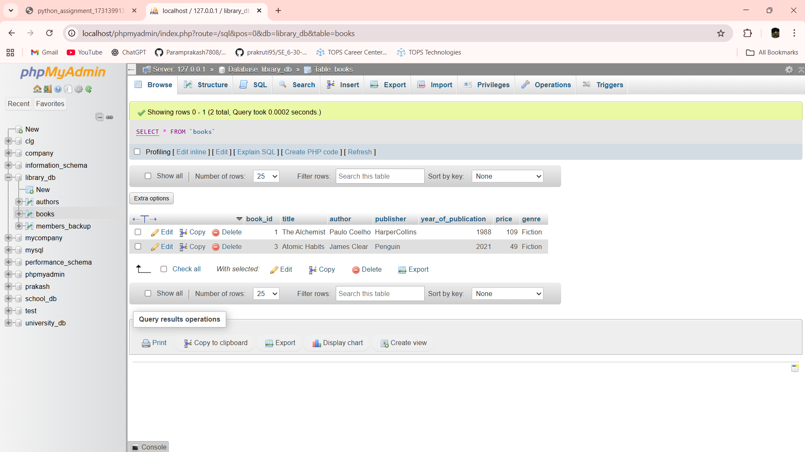

Lab 10.4: Write a query to retrieve all books with price between $50 and $100.

Ans:- SELECT * FROM books WHERE price BETWEEN 50 AND 100

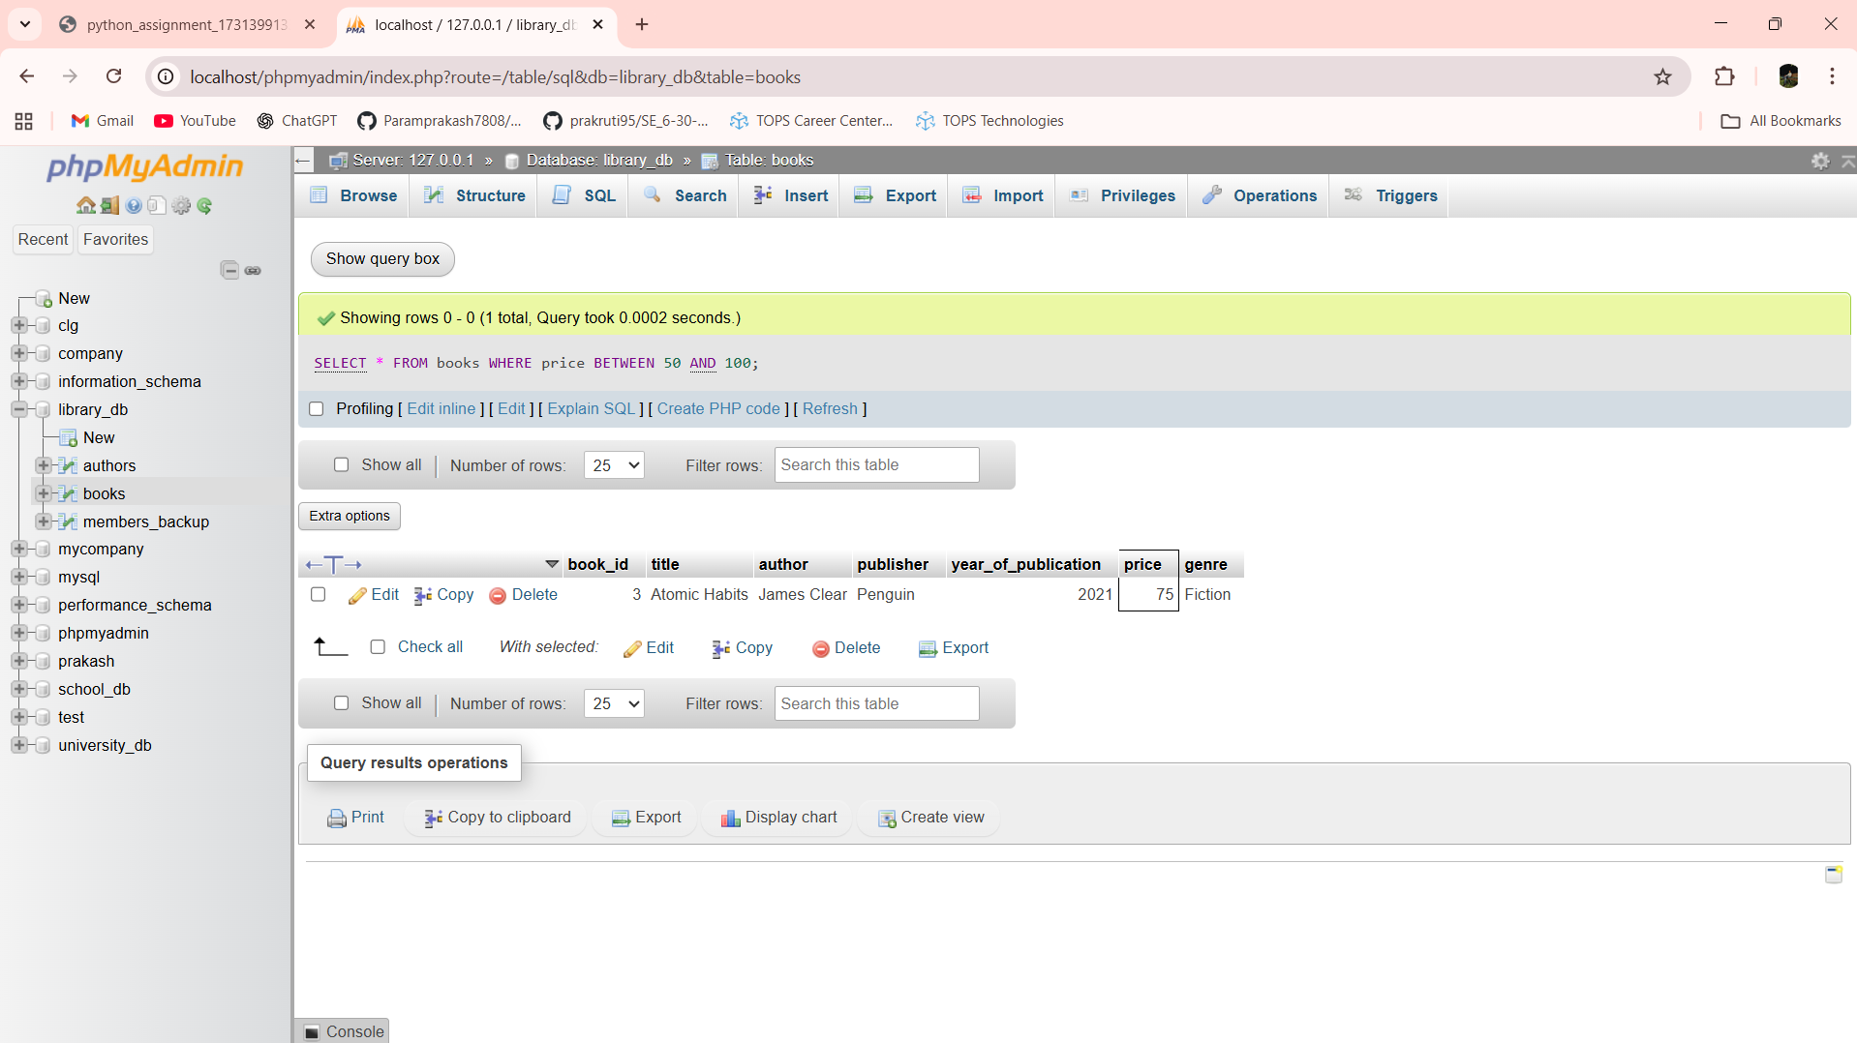

Lab 10.5: Retrieve the list of books sorted by author in ascending order and limit the results to the top 3 entries.

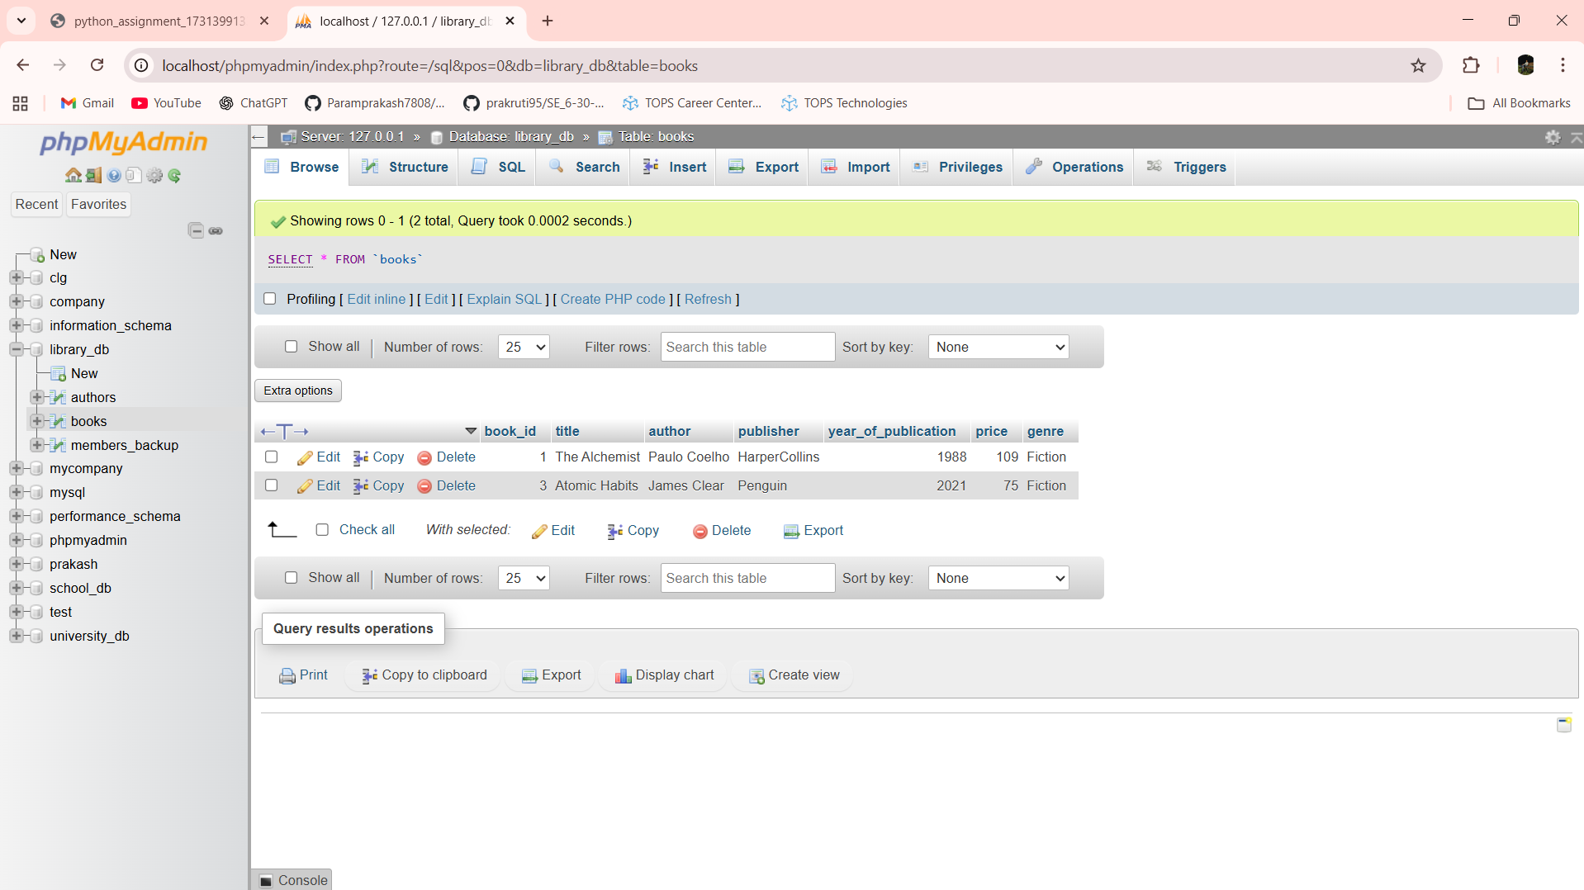

SELECT * FROM books ORDER BY author ASC LIMIT 1

